Caboteja, Steven

Delafer, John Fritz

Devera, Austine

Gacilo, Ariel Jericko

Ona, Jayrell

**PROJECT IN MOBILE SYSTEM AND TECHNOLOGY**

**December 13, 2022**

**Activity 1: Signin View**

This will the starting point or activity of our app Codex. In this view, you will see our app logo, app title and the sign in using Google account button. If you click the sign in button, the app redirects you to sign in using Google account. This will use Google Authenticate API services in order to implement and fetch the information of your Google account. After successful sign in, Codex will redirect you to the next activity (view_snippets).

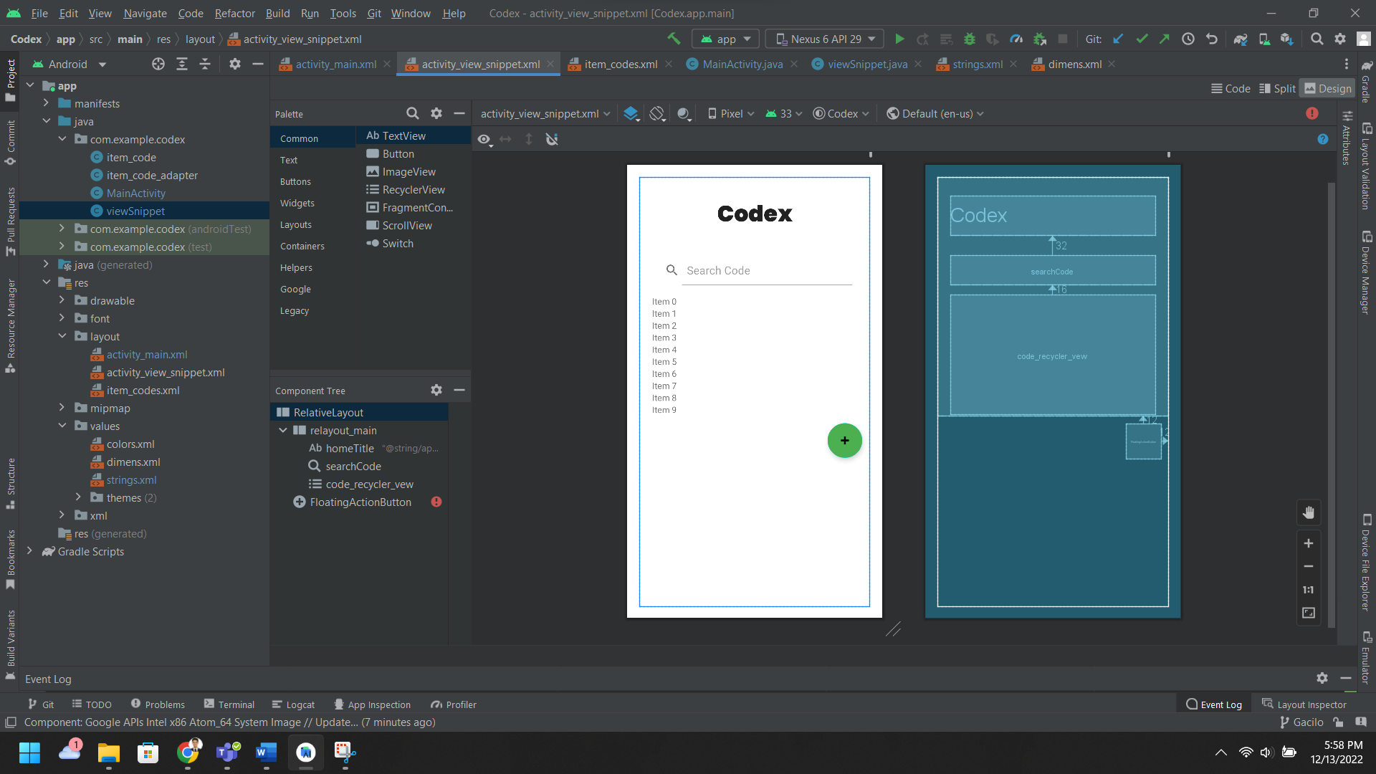

**Activity 2: View Snipets View**

After successful sign in, this is the next activity. In this activity, you can see the app title, search box, list of items and a floating action button. The floating action button is for creating/importing note format (.TXT) of your snippets. Using Firebase Storage, Codex will put your imports file to our Firebase Storage, to be more accessible to different platforms. Codex will display all the imported snippets on the Firebase Storage. Codex will listed down all the snippets and add an click event listener to it in order to make it viewable using the third activity (item_codes). The search box is used to search specific or keyword of your snippets so that you can easily get what you want to see when you have many snippets uploaded to the Codex.

**Activity 3: Item Codes (Snippet) View**

This will show the content of the text file of your uploaded snippet. This activity show the actual content and file name of the uploaded snippet to the Firebase database. We uses text file format for compatibility, small file size, and ease to use.